For part 2 of this program, here’s my to each “task” we had to solve:

1. Loop from 1000 to 9999
   1. I simply set up a loop in the same way as before, but this time it compares both the upper bit register and the lower bit register to make sure it hasn’t exceeded 9999.
2. If the return from tester is 1, store the lpcnt in data memory.
   1. Use the ST operand to store stuff to data memory, only doing so if rtrnVal = 1 (using a compare and branch to ensure that).

For proof of the program working, here is the data memory after the program runs. $0x04D1=1233D$ and $0x2281=8833D$.

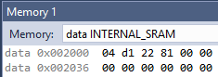

In addition, here is Part 3, an equivalent C program & its result:

